Hands-on Lab: String Patterns, Sorting and Grouping in MySQL

CREATE TABLE EMPLOYEES (
EMP_ID CHAR(9) NOT NULL,
F_NAME VARCHAR(15) NOT NULL,
L_NAME VARCHAR(15) NOT NULL,
SSN CHAR(9),
B_DATE DATE,
SEX CHAR,
ADDRESS VARCHAR(30),
JOB_ID CHAR(9),
SALARY DECIMAL(10,2),
MANAGER_ID CHAR(9),
DEP_ID CHAR(9) NOT NULL,
PRIMARY KEY (EMP_ID));

CREATE TABLE JOB_HISTORY (
EMPL_ID CHAR(9) NOT NULL,
START_DATE DATE,
JOBS_ID CHAR(9) NOT NULL,
DEPT_ID CHAR(9),
PRIMARY KEY (EMPL_ID,JOBS_ID));

CREATE TABLE JOBS (
JOB_IDENT CHAR(9) NOT NULL,
JOB_TITLE VARCHAR(30),
MIN_SALARY DECIMAL(10,2),
MAX_SALARY DECIMAL(10,2),
PRIMARY KEY (JOB_IDENT));

CREATE TABLE DEPARTMENTS (
DEPT_ID_DEP CHAR(9) NOT NULL,
DEP_NAME VARCHAR(15) ,
MANAGER_ID CHAR(9),
LOC_ID CHAR(9),
PRIMARY KEY (DEPT_ID_DEP));

CREATE TABLE LOCATIONS (
LOCT_ID CHAR(9) NOT NULL,
DEP_ID_LOC CHAR(9) NOT NULL,
PRIMARY KEY (LOCT_ID,DEP_ID_LOC));
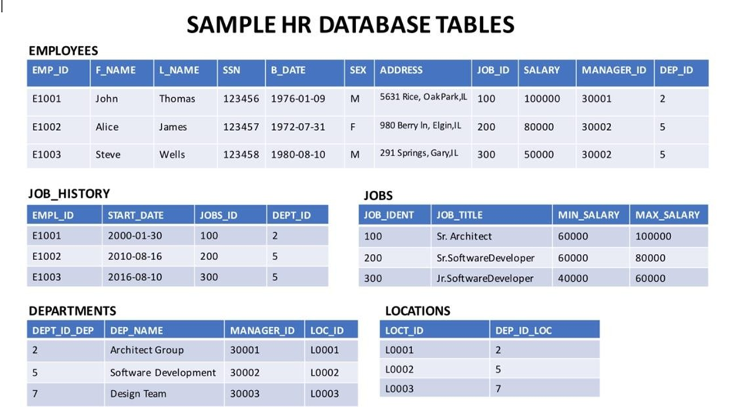

Download the files in the links below to your local machine (if not already done in previous labs).
Departments.csv
Jobs.csv
JobsHistory.csv
Locations.csv
Employees.csv

Questions:
- Retrieve all employees whose address is in Elgin,IL
- Retrieve all employees in department 5 whose salary is between 60000 and 70000.
- Retrieve a list of employees ordered by department ID.
- For each department ID retrieve the number of employees in the department
- For each department retrieve the number of employees in the department, and the average employee salary in the department..
- For each department retrieve the number of employees in the department, and the average employee salary in the department and limit the result to departments with fewer than 4 employees.

Hands-on Lab: Built-in Functions

create table PETRESCUE (
ID INTEGER NOT NULL,
ANIMAL VARCHAR(20),
QUANTITY INTEGER,
COST DECIMAL(6,2),
RESCUEDATE DATE,
PRIMARY KEY (ID)
);

insert into PETRESCUE values
(1,'Cat',9,450.09,'2018-05-29'),
(2,'Dog',3,666.66,'2018-06-01'),
(3,'Dog',1,100.00,'2018-06-04'),
(4,'Parrot',2,50.00,'2018-06-04'),
(5,'Dog',1,75.75,'2018-06-10'),
(6,'Hamster',6,60.60,'2018-06-11'),
(7,'Cat',1,44.44,'2018-06-11'),
(8,'Goldfish',24,48.48,'2018-06-14'),
(9,'Dog',2,222.22,'2018-06-15')

;

Questions Aggregate Functions:
Query A1: Enter a function that calculates the total cost of all animal rescues in the PETRESCUE table.
Query A2: Enter a function that displays the total cost of all animal rescues in the PETRESCUE table in a column called SUM_OF_COST.
Query A3: Enter a function that displays the maximum quantity of animals rescued. Query A4: Enter a function that displays the average cost of animals rescued.
Query A5: Enter a function that displays the average cost of rescuing a dog.

Questions Scalar and String Functions:
Query B1: Enter a function that displays the rounded cost of each rescue.
Query B2: Enter a function that displays the length of each animal name.
Query B3: Enter a function that displays the animal name in each rescue in uppercase. Query B4: Enter a function that displays the animal name in each rescue in uppercase without duplications.
Query B5: Enter a query that displays all the columns from the PETRESCUE table, where the animal(s) rescued are cats. Use cat in lower case in the query.
Questions Date and Time Functions:
Query C1: Enter a function that displays the day of the month when cats have been rescued.
Query C2: Enter a function that displays the number of rescues on the 5th month.
Query C3: Enter a function that displays the number of rescues on the 14th day of the month.
Query C4: Animals rescued should see the vet within three days of arrivals. Enter a function that displays the third day from each rescue.
Query C5: Enter a function that displays the length of time the animals have been rescued; the difference between todays date and the rescue date.

